PUXAR ZPL PARA IMPRESSAO

ESTRUTURA COM OS CAMPOS NECESSARIOS
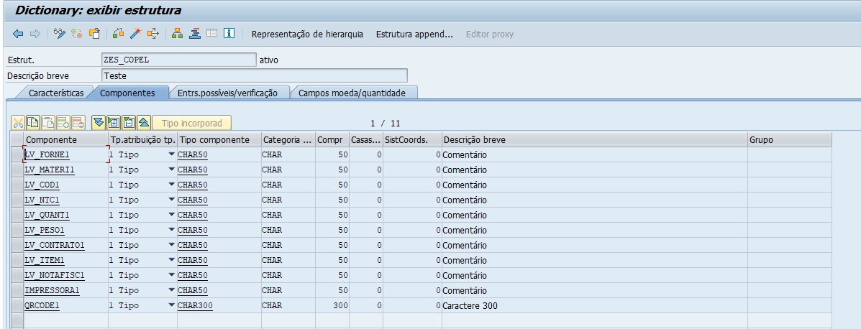

CRIAR UMA FUNÇÃO NA SE37
IMPORTA OS CAMPOS DA ESTRUTURA
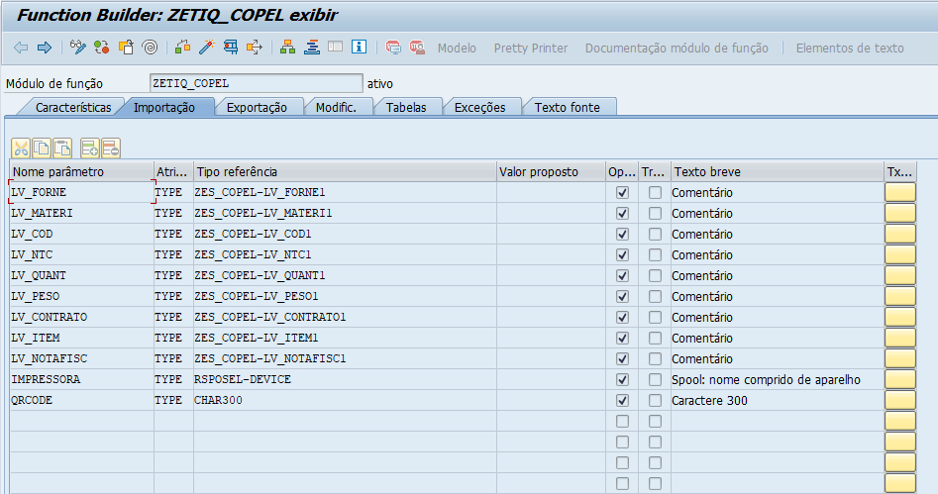

ERRO E MENSAGEM
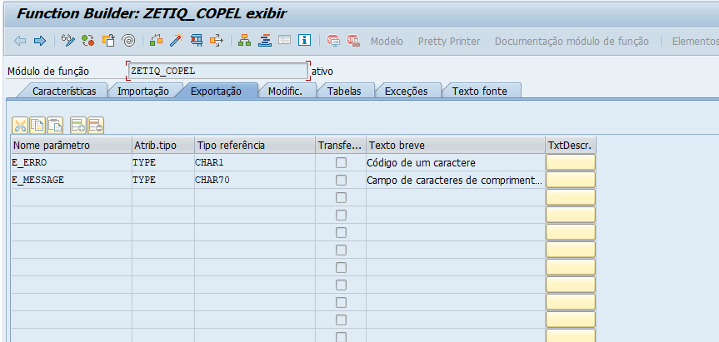

CÓDIGO:

DATA: lv_zpl TYPE string,
lt_zpl_lines TYPE stringtab.
DATA: ls_tsp03 TYPE tsp03.
" Verifica se a impressora existe na TSP03
SELECT SINGLE * INTO ls_tsp03
FROM tsp03
WHERE padest = IMPRESSORA.
IF sy-subrc <> 0.
e_erro = 'X'.
e_message = 'Impressora não cadastrada'.
EXIT.
ENDIF.
" Monta comando ZPL
lv_zpl = '^XA'.
APPEND lv_zpl TO lt_zpl_lines.
lv_zpl = '^FO300,45^GFA,1375,1375,25,,1IFCJ0IFE,0IFEI01IFC,07IFI01IFC,07IFI03IF8,0'.
APPEND lv_zpl TO lt_zpl_lines.
lv_zpl = '3IF8007IF,:01IFC00IFE,01IFE00IFE,00IFE01IFC,007IF03IFC,007IF03IF8,003FK0'.
APPEND lv_zpl TO lt_zpl_lines.
lv_zpl = '3F,7IFK03IF8M038K078,3IF8J07IF8L03FFJ07FFI07FFC00JF83E,3IF8J07IFM0IFCI0I'.
APPEND lv_zpl TO lt_zpl_lines.
lv_zpl = 'FC007IF80JF83E,1IFCJ0IFEL01IFE003IFE007IFC0JF83E,1IFEJ0IFEL03E03F007E01F'.
APPEND lv_zpl TO lt_zpl_lines.
lv_zpl = '007C0FE0FJ03E,0IFEI01IFCL07C00F807C00F807803E0FJ03E,07IFI03IFCL07800F80F'.
APPEND lv_zpl TO lt_zpl_lines.
lv_zpl = '8007C07801F0FJ03E,07IFI03IF8L0F8007C0FI07C07801F0FJ03E,03IF8007IFM0FI07C'.
APPEND lv_zpl TO lt_zpl_lines.
lv_zpl = '1FI03C07801F0FJ03E,03IF8007IFM0FK01FI03E07801F0FJ03E,01IFC00IFEL01FK01EI'.
APPEND lv_zpl TO lt_zpl_lines.
lv_zpl = '03E07801F0FJ03E,X01FK01EI03E07801F0FJ03E,X01FK01EI01E07803E0JF03E,X01FK0'.
APPEND lv_zpl TO lt_zpl_lines.
lv_zpl = '1EI01E0780FE0JF03E,X01FK01EI01E07IFC0JF03E,01IFC00IFEL01FK01EI01E07IF80J'.
APPEND lv_zpl TO lt_zpl_lines.
lv_zpl = 'F03E,03IF8007IFL01FK01EI01E07FFE00FJ03E,03IF8007IFL01FK01EI03E078J0FJ03E'.
APPEND lv_zpl TO lt_zpl_lines.
lv_zpl = ',07IFI03IF8K01FK01FI03E078J0FJ03E,07IFI03IFCL0FK01FI03E078J0FJ03E,0IFEI0'.
APPEND lv_zpl TO lt_zpl_lines.
lv_zpl = '1IFCL0FI07C1FI03C078J0FJ03E,1IFCJ0IFEL0F800780FI07C078J0FJ03E,1IFCJ0IFEL'.
APPEND lv_zpl TO lt_zpl_lines.
lv_zpl = '07800F80F8007C078J0FJ03E,3IF8J07IFL07C00F807C00F8078J0FJ03E,3IF8J07IF8K0'.
APPEND lv_zpl TO lt_zpl_lines.
lv_zpl = '3F03F007E03F0078J0F8I03E,7IFK03IF8K01IFE003IFE0078J0JF83IFC,003FK03FO0IF'.
APPEND lv_zpl TO lt_zpl_lines.
APPEND lv_zpl TO lt_zpl_lines.
lv_zpl = 'CI0IFC0078J0JF83IFC,007IF03IF8N03FFJ03FFI078J0JF83IFC,007IF03IFC,00IFE01'.
APPEND lv_zpl TO lt_zpl_lines.
lv_zpl = 'IFC,01IFE00IFE,01IFC00IFE,03IF8007IF,:07IFI03IF8,07IFI01IFC,0IFEI01IFC,1'.
APPEND lv_zpl TO lt_zpl_lines.
lv_zpl = 'IFCJ0IFE,,:::^FS'.
APPEND lv_zpl TO lt_zpl_lines.
lv_zpl = '^CI28'.
APPEND lv_zpl TO lt_zpl_lines.
lv_zpl = '^LL800'.
APPEND lv_zpl TO lt_zpl_lines.
lv_zpl = '^FO0,0^GB800,800,4^FS'.
APPEND lv_zpl TO lt_zpl_lines.
lv_zpl = '^FO0,140^GB800,4,4^FS'.
APPEND lv_zpl TO lt_zpl_lines.
lv_zpl = '^FO340,140^GB4,660,4^FS'.
APPEND lv_zpl TO lt_zpl_lines.
lv_zpl = '^FO340,215^GB460,2,2^FS'.
APPEND lv_zpl TO lt_zpl_lines.
lv_zpl = '^FO340,290^GB460,2,2^FS'.
APPEND lv_zpl TO lt_zpl_lines.
lv_zpl = '^FO340,365^GB460,2,2^FS'.
APPEND lv_zpl TO lt_zpl_lines.
lv_zpl = '^FO340,440^GB460,2,2^FS'.
APPEND lv_zpl TO lt_zpl_lines.
lv_zpl = '^FO340,515^GB460,2,2^FS'.
APPEND lv_zpl TO lt_zpl_lines.
lv_zpl = '^FO340,590^GB460,2,2^FS'.
APPEND lv_zpl TO lt_zpl_lines.
lv_zpl = '^FO340,665^GB460,2,2^FS'.
APPEND lv_zpl TO lt_zpl_lines.
lv_zpl = '^FO340,740^GB460,2,2^FS'.
APPEND lv_zpl TO lt_zpl_lines.
lv_zpl = '^FO20,55^A0N,35,28^FDSAP - RECEBIMENTO^FS'.
APPEND lv_zpl TO lt_zpl_lines.
lv_zpl = '^FO55,320^BQN,2,10^FDQA,' && QRCODE && '^FS'.
APPEND lv_zpl TO lt_zpl_lines.
lv_zpl = '^FO75,700^A0N,45,45^FDEXEMPLO^FS'.
APPEND lv_zpl TO lt_zpl_lines.
lv_zpl = '^CF0,22,22 '.
APPEND lv_zpl TO lt_zpl_lines.
lv_zpl = '^FO350,165^FDFORNECEDOR:^FS'.
APPEND lv_zpl TO lt_zpl_lines.
lv_zpl = '^FO485,165^FD' && LV_FORNE && '^FS'.
APPEND lv_zpl TO lt_zpl_lines.
lv_zpl = '^FO350,240^FDMATERIAL:^FS'.
APPEND lv_zpl TO lt_zpl_lines.
lv_zpl = '^FO460,240^FD' && LV_MATERI && '^FS'.
APPEND lv_zpl TO lt_zpl_lines.
lv_zpl = '^FO350,315^FDCÓDIGO:^FS'.
APPEND lv_zpl TO lt_zpl_lines.
lv_zpl = '^FO435,315^FD' && LV_COD && '^FS'.
APPEND lv_zpl TO lt_zpl_lines.
lv_zpl = '^FO355,395^FDNTC:^FS'.
APPEND lv_zpl TO lt_zpl_lines.
lv_zpl = '^FO405,395^FD' && LV_NTC && '^FS'.
APPEND lv_zpl TO lt_zpl_lines.
lv_zpl = '^FO350,465^FDQUANTIDADE:^FS'.
APPEND lv_zpl TO lt_zpl_lines.
lv_zpl = '^FO480,465^FD' && LV_QUANT && '^FS'.
APPEND lv_zpl TO lt_zpl_lines.
lv_zpl = '^FO350,540^FDPESO BRUTO:^FS'.
APPEND lv_zpl TO lt_zpl_lines.
lv_zpl = '^FO480,540^FD' && LV_PESO && '^FS'.
APPEND lv_zpl TO lt_zpl_lines.
lv_zpl = '^FO350,615^FDCONTRATO:^FS'.
APPEND lv_zpl TO lt_zpl_lines.
lv_zpl = '^FO460,615^FD' && LV_CONTRATO && '^FS'.
APPEND lv_zpl TO lt_zpl_lines.
lv_zpl = '^FO350,690^FDITEM:^FS'.
APPEND lv_zpl TO lt_zpl_lines.
lv_zpl = '^FO410,690^FD' && LV_ITEM && '^FS'.
APPEND lv_zpl TO lt_zpl_lines.
lv_zpl = '^FO350,760^FDN. NOTA FISCAL:^FS'.
APPEND lv_zpl TO lt_zpl_lines.
lv_zpl = '^FO510,760^FD' && LV_NOTAFISC && '^FS'.
APPEND lv_zpl TO lt_zpl_lines.
lv_zpl = '^XZ'.
APPEND lv_zpl TO lt_zpl_lines.
NeW-PAGE PRINT ON
DESTINATION IMPRESSORA
IMMEDIATELY 'X'
NEW LIST IDENTIFICATION 'ZETIQUETA16X7'
NO DIALOG.
LOOP AT lt_zpl_lines INTO lv_zpl.
WRITE: / lv_zpl.
ENDLOOP.
NEW-PAGE PRINT OFF.
E_MESSAGE = 'Etiqueta impressa'.
ENDFUNCTION.

